MEDIA RELEASE 05/11/2014

DOLTONE HOUSE CELEBRATES BECOMING BEST IN THE NATION AT THE RESTAURANT & CATERING AWARDS FOR EXCELLENCE

The 2014 Savour Australia™ Restaurant & Catering HOSTPLUS Awards for Excellence - National winners have been announced. 185 restaurants and 59 caterers from metropolitan and regional areas across the country have been recognised for their outstanding commitment to quality and service at the industry’s gala night of night’s celebration held at Peninsula in Victoria.

Doltone House located in Sydney has become National Winner of the Wedding Caterer of the year. Steven Cesarano, Director of Weddings, accepted the award on behalf of the team and stated “it is a proud acknowledgement of our quality and consistency as we continually strive to achieve new highs in making our wedding clients happy”.
Becoming a national winner is an incredible attribute and well-deserved recognition of this great business.

The Awards for Excellence program has seen its 16th year and the National event is a culmination of winners from 8 events held around Australia with around 1200 businesses participating in the 2014 program. Through the RACES Evaluation System venues were assessed by trained judges who dine anonymously and review the experience according to a predetermined, research-based and standardised set of criteria, making it the only truly systematic restaurant industry awards program in Australia. The judging process provides a benchmark for businesses that are involved and is specifically designed to objectively recognise and promote industry best practice.

John Hart, CEO Restaurant & Catering commented, “Restaurant & Catering congratulates all the winners and finalists in the 2014 National Awards. Their achievement in providing great food and great service is in itself, a wonderful contribution to the industry. The Awards for Excellence represent an important moment as the industry pauses to honour these outstanding venues for their great talent, innovation and commitment and to celebrate such well-deserved accolades.”

Restaurant & Catering is committed to supporting the professionalism and sustainability of the Australian hospitality industry and is delighted to announce the finalists and winners of the 2014 Awards Program.
Please see the attached Finalists and Winners List for a complete list of the 37 National categories in the 2014 Savour Australia™ Restaurant & Catering HOSTPLUS Awards for Excellence – National

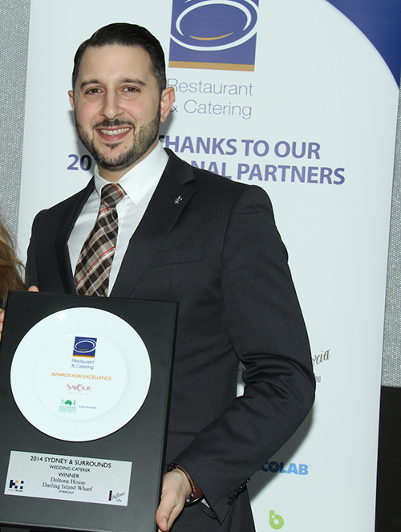

For images, interviews and further media information please contact:
Phone: 02 8571 0622 | Email: marketing@doltonehouse.com.au

