DOLTONE HOUSE INDUCTED INTO MEA HALL OF FAME

Renowned venue and catering collection, Doltone House have been inducted into Meetings & Events Australia Hall of Fame as Australia’s leading specialty meeting venues.

Doltone House has been announced as National Winner of the 2013/2014 Meetings and Events Australia (MEA) Industry Award for the Specialty Meeting Venue category.

Following three consecutive national wins in the same category, Doltone House were thrilled to qualify and be inducted into the MEA Hall of Fame and also as inaugural inductees in this category. The award acknowledges Australia’s leading meetings and events specialists.

The MEA National Awards were held in Kuala Lumpur on the 17th of May 2014. “We are thrilled to have reached our hall of fame goal, leaving us with so much to celebrate about” said CEO Anna Cesarano earlier today.

But the accolades continued as Doltone House were also proud recipients of the National Cause Related Event of The Year for the Biaggio Signorelli Foundation annual fundraiser for Asbestos Cancer; honouring the late founder of Doltone House. This was a second national win in this category and a great reward for the corporate social responsibility contribution from Doltone Houses’ Directors. They set up a not for profit foundation in 2009 and have committed almost $2million over 5 years for asbestos cancer research. “We are committed to this cause as my father’s dying wish was for us to help save others” said Executive Chairman, Paul Signorelli.

MEA is a national, independent not for profit organisation dedicated to fostering professionalism and excellence in all aspects of meetings and event management. MEA is the largest national association of individuals and businesses covering all sectors of the vibrant industry of meetings, conferences, exhibitions and events.

Doltone House is renowned in Sydney for providing multi award-winning, iconic venues for conferences and events. The Doltone House property portfolio includes iconic waterfront flagship properties in Pyrmont, Jones Bay Wharf and Darling Island Wharf, Sylvania Waters located near Sydney Airport and the newly opened Hyde Park CBD venue in Elizabeth Street Sydney, has seen Doltone House establish a reputation as one of Australia’s premier venue and catering collection.

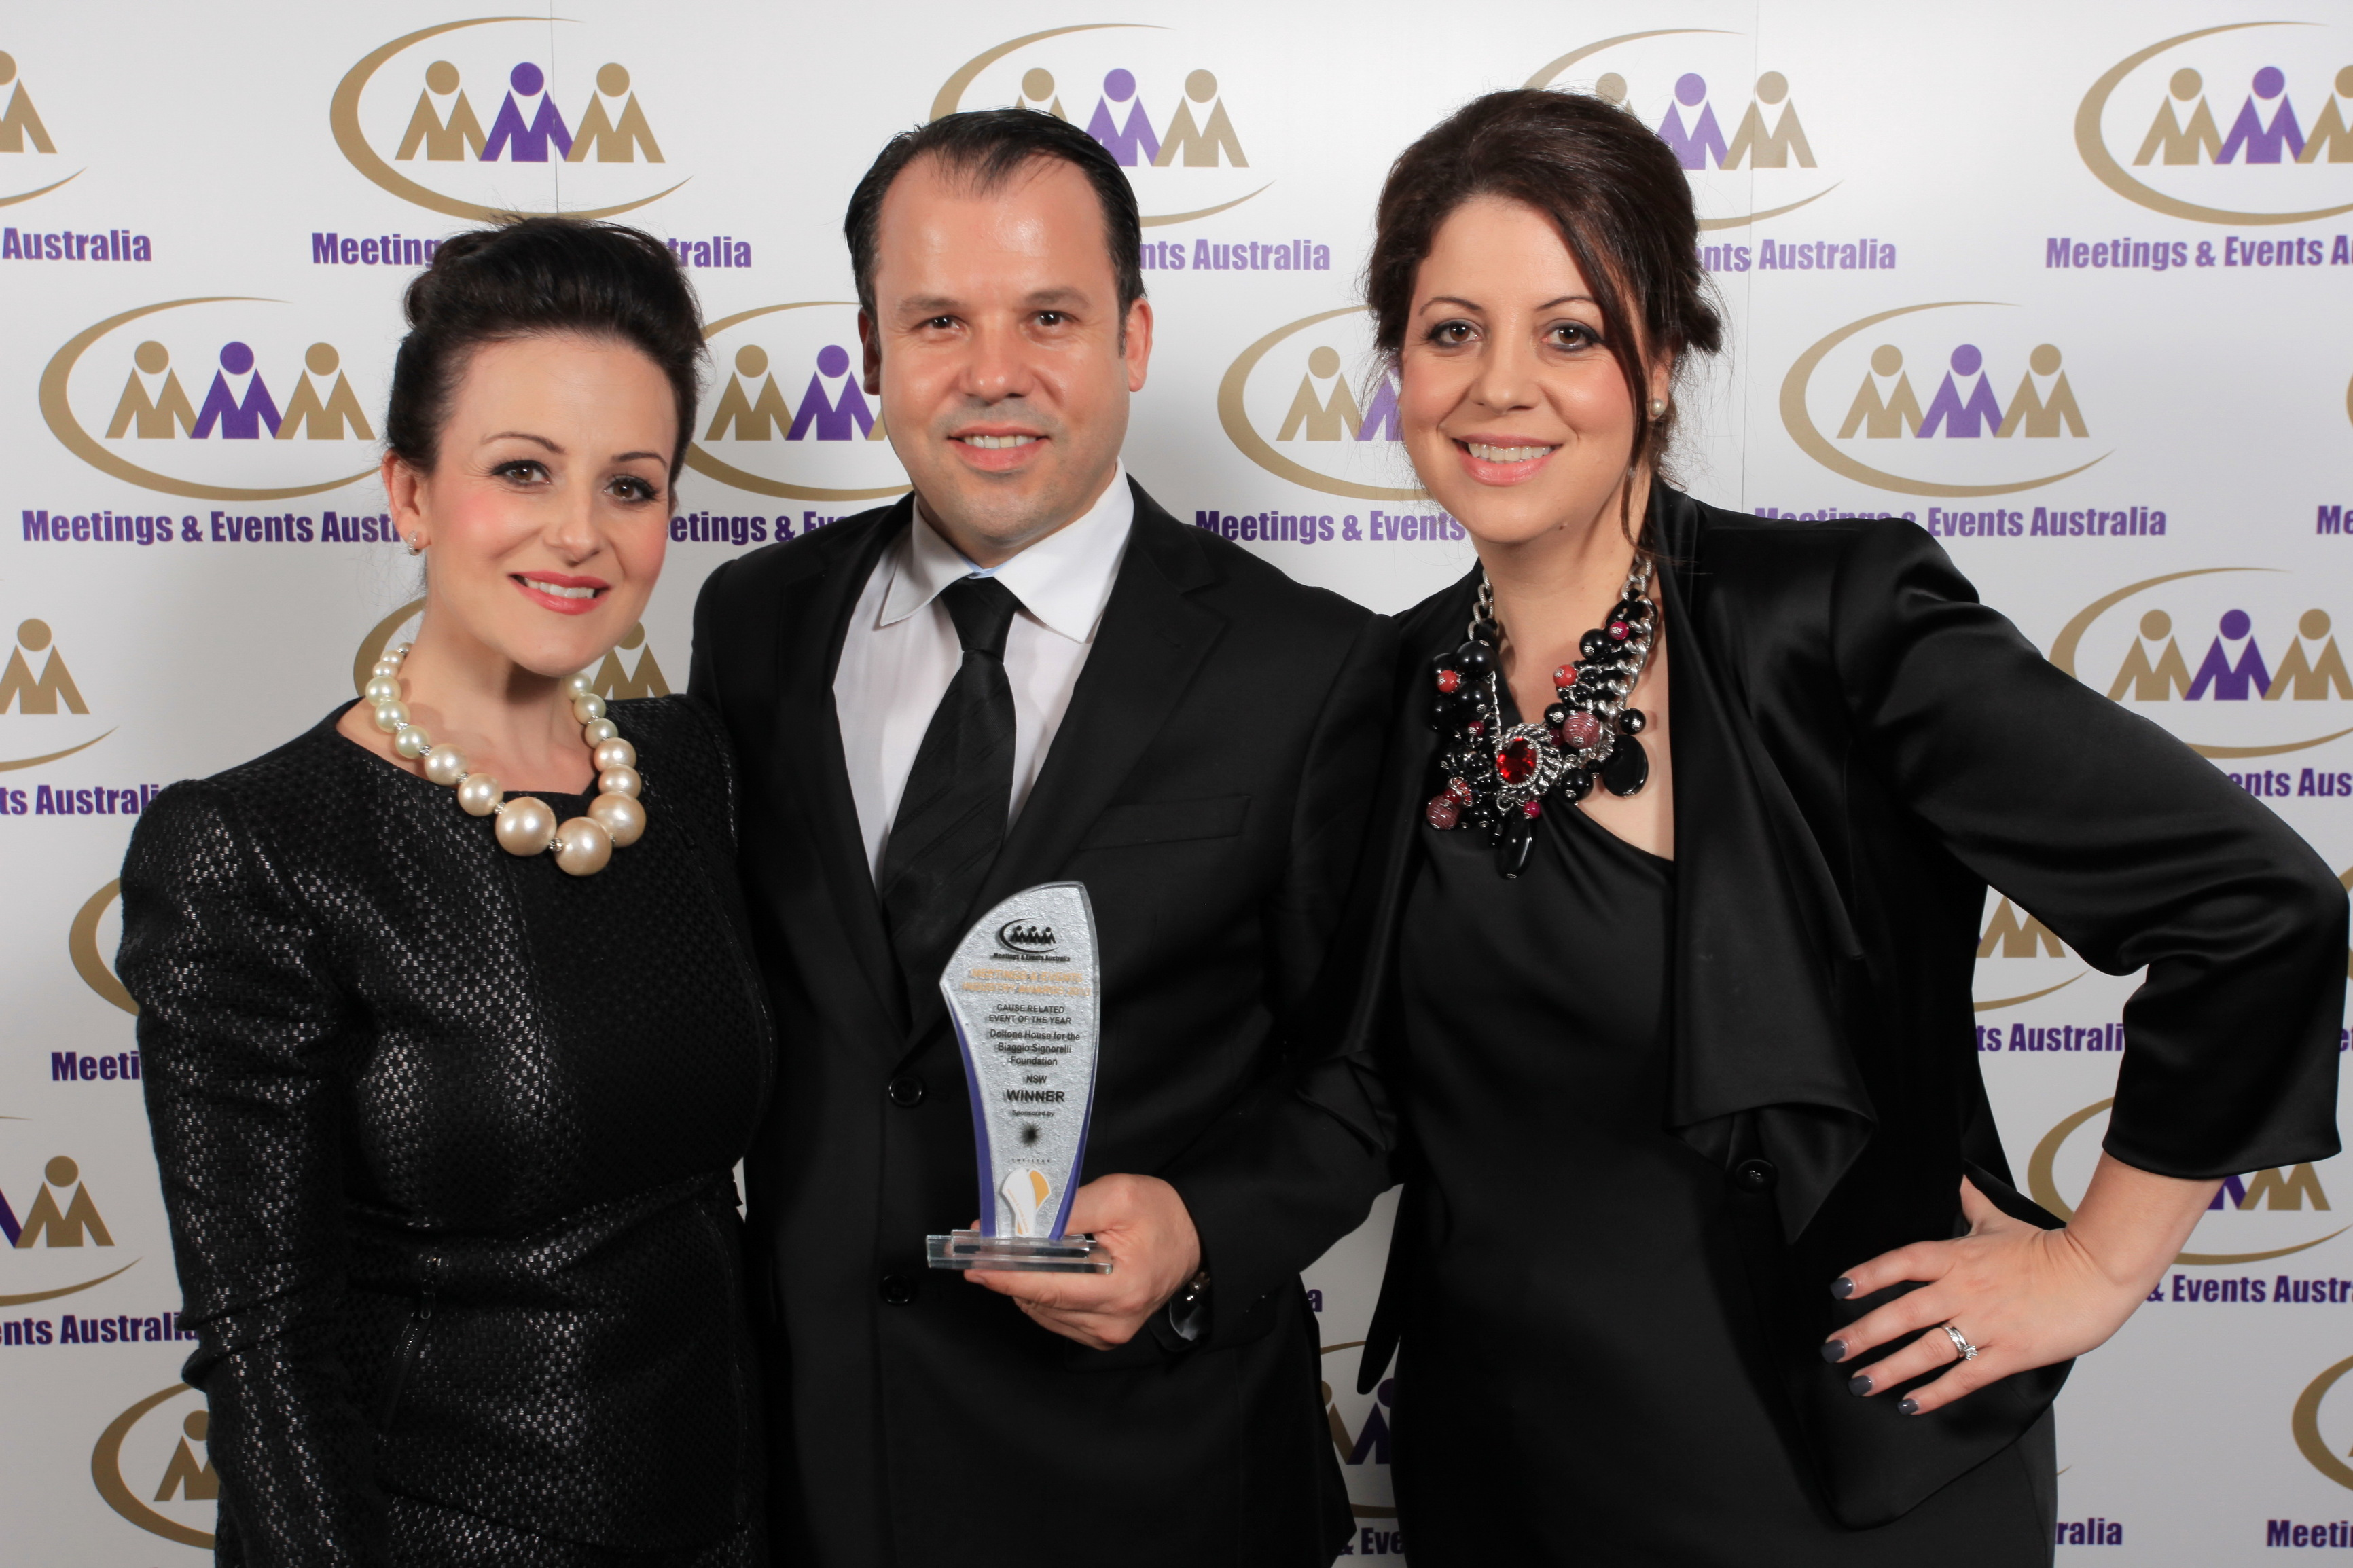

For images, interviews and further media information please contact:
Phone: 02 8571 0622 | Email: marketing@doltonehouse.com.au

